**Project Title :** Airbnb’s in Asheville, NC

**Team Members:** Janani Sekar, Preethika Gajendran, Rashi Waghray, Surabhi Sood

**Project Description / Outline:**

This project identifies local Airbnb’s in Asheville, NC region.

**Datasets used:**

|  |  |  |  |
| --- | --- | --- | --- |
| **Dataset Description** | **Type** | **Source** | **Link** |
| The dataset contains details of listings, reviews, calendar data for listings, etc. of Asheville, NCfor Airbnb listings to help analyze the growth of Airbnb. | CSV, GeoJSON | Insideairbnb | <http://insideairbnb.com/get-the-data.html> |

**Screenshots of relevant, “inspiring” visualizations / Doodles**

<https://towardsdatascience.com/airbnb-rental-listings-dataset-mining-f972ed08ddec>

<https://medium.com/ml2vec/data-analysis-on-the-airbnb-dataset-e0be9254eeb9>

**Sketch of final design**

Basic filtering – add on more features as possible

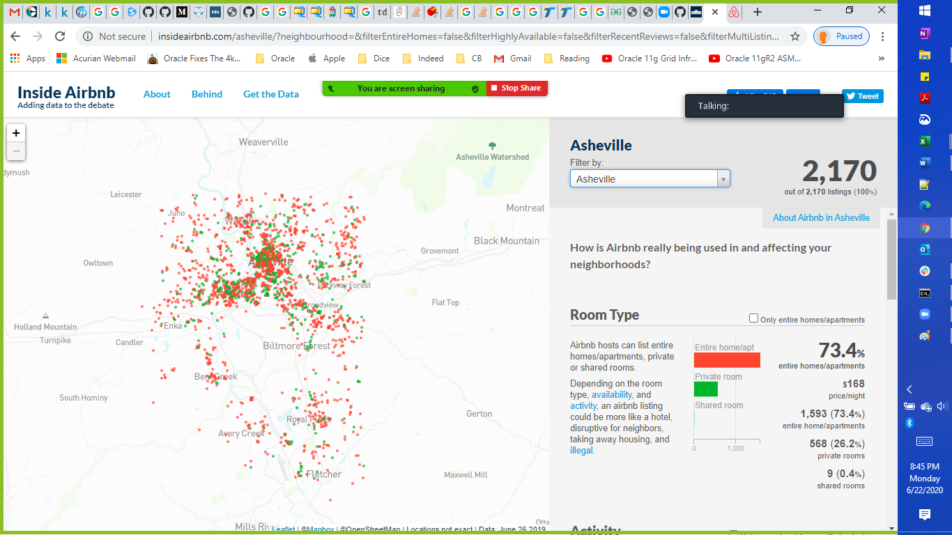

**Link to the primary GitHub repository used to house -** <https://github.com/PreethikaG/Project-2>

**Rough Breakdown of Tasks:**

|  |  |
| --- | --- |
| **Task** | **Description** |
| **Extract** | |
| 1 | Extracted the CSV file to a Pandas DataFrame  (Listings, Calendar, Reviews, Neighborhood ) |
| 2 | Neighborhood – GeoJSON |
| **Transform** | |
| 1 | Updated datatypes of certain columns used in analysis |
| 2 | Filtered & grouped and performed aggregations for relevant columns using Pandas |
| 3 | Cleaned the data set by deleting null data values from the analysis |
| 4 | Renamed columns for standardization & consistency |
| **Load** | |
| 1 | Developed the table schema using QuickDBD for tables to be loaded in the Postgres database |
| 2 | Imported the table schema from QuickDBD to create the tables in the Postgres database |
| 3 | Created a connection with the PostgreSQL database using SQLAlchemy |
| 4 | Stored the final datasets into PostgreSQL using SQLAlchemy |
| **Statistical Analysis** | |
| 1 | Top listings based on ratings |
| 2 | Top 5 places to visit/things to do/local restaurant info display |
| **Web Visualization** | |
| 1 | User driven interface – Menu’s dropdowns, Forms |
| 2 | Plotly – bar plot (Based on room type) |
| 3 | Leaflet – Cluster Markers (Based on user selection), Choropleth (based on price) |
| 4 | JS Library – TBD |
| **Deploy** | |
| 1 | Create Flask App |
| 2 | Deploy to Heroku |